**CS3354 Software Engineering**

**Final Project Deliverable 1**

# Scribble

Nicole Iwuala  
Harini Arunprakash  
Zaaim Rahman  
Nicholas Donovan  
Muhammad Ali  
Amir Akilimali  
Aditya Sinha  
Pranav Balu

# Table of Contents

**Scribble** **1**

**Table of Contents** **2**

**Overview** **4**

**Our Project** **5**

**Our Developers** **5**

**Our Methodology** **6**

**Functional Requirements** **7**

User Functionalities 7

Dynamic Communications 7

Messaging 7

Session Management 7

System Functionalities 7

Gestures 7

Notifications 7

**Non-Functional Requirements** **8**

Dependability 8

Security 8

Regulatory 8

Ethical 9

Usability 9

Environmental 9

Operational 10

Development 10

Performance 10

Space 10

Accounting 10

Safety/Security 11

**Use-Case Diagrams** **12**

Client-to-Client 12

Client-to-Server 12

**Sequence Diagrams** **13**

Login 13

Create Group Session 14

Edit Message 15

Send Message 15

Draw 16

Save Drawings 16

Retrieve Drawings 17

Draw Graphics 17

**Class Diagram** **18**

**Architectural Design** **19**

**Conclusion** **20**

# 

# Overview

The motivation for tackling this project stems from the growing need for efficient communication in today’s digital age. We recognize the importance of understanding technology in everyday life. Our goal is to provide a solution that not only facilitates communication but also enhances productivity, connectivity, and convenience in a world which requires instantaneous communication. The primary goal of our group is to build an instant messenger with a focus on accessibility, intuitive design, and simplicity. We envision our platform being used in various real-life scenarios, including personal communication, professional collaboration, and community building, catering to the diverse communication needs of individuals, teams, and organizations.

*Good choice for a topic! Messages are an inherent part of our lives now and organizing them is becoming more and more of a requirement.*

*It is great to see a detailed breakdown of the tasks you have worked on already. Good job.*

*In the final report, please make sure to include comparison with similar applications -if any-, make sure that you differentiate your design from those, and explicitly specify how.*

*Fair delegation of tasks.*

*Please share this feedback with your group members.*

*You are good to go. Have fun with the project and hope everyone enjoys the collaboration.*

In the current collaborative landscape, messaging, and efficient communication are essential. In addition to our initial proposal, we have developed and incorporated a distinctive feature that sets us apart from other messaging platforms. We have all experienced the desire for better communication, feeling limited by text. We have overcome the issue by introducing a new feature that allows hand-drawn scribbles to be displayed over text, ushering in a new era of messaging.

# Our Project

<https://github.com/nick-donovan-utd/3345-TheSKidSociety>

# Our Developers

**Nicole Iwuala**

I did a large portion of the non-functional requirements; revised and edited some of the functional requirements; made two of the sequence diagrams; made the project scope commit in GitHub; helped brainstorm use cases; and helped organize our shared Google Drive. For Deliverable 2, I plan to contribute to the cost, effort, and pricing estimation portion and the presentation content and design. I will also be involved in the test plan to give feedback and edits.

**Harini Arunprakash**

I worked on the use-case diagrams. For Deliverable 2, I plan to contribute to project scheduling as well as the cost, effort, and pricing estimation portion.

**Zaaim Rahman**

I worked on constructing the functional requirements to specify our application’s desired goals for our project and designing/constructing the class diagram’s various classes and flow of information. For Deliverable 2, I will work on the project test plan and the presentation content.

**Nicholas Donovan**

I created the project GitHub repository, revised and edited some of the non-functional requirements, created the architectural design with Muhammad, provided input for the class diagram, and drafted the Deliverable 1 report. My responsibilities for Deliverable 2 involve creating the project test plan, evaluating our projects’ similarities to other relevant works, and assisting with the presentation.

**Muhammad Ali**

I worked on the use-case diagrams and architectural design for the project. For Deliverable 2, I plan to work on the testing, comparison to similar projects, and presentation.

**Amir Akilimali**

I did two of the sequence diagrams. I plan to contribute to the testing plan for Deliverable 2.

**Aditya Sinha**

I worked on the non-functional requirements and the class diagram. I plan to contribute to project scheduling for Deliverable 2.

**Pranav Balu**

I worked on sequence diagrams and helped brainstorm ideas for implementation of the project. For Deliverable 2, I intend to work on the slides, implementation, and presentation.

# Our Methodology

We adopted the Agile methodology for our instant messenger. Agile enables our small team of developers with diverse specialties to concentrate on the software and the projects’ vision, rather than extensively planning the design. Its iterative approach enables Scribble to become adaptable to changing requirements and environments while fostering collaboration within our team. Moreover, Agile enables us to enhance our messenger continuously by implementing incremental improvements, new features, and additions while preserving its heart.

# Functional Requirements

The functional requirements of our software project lay out the services and capabilities our application will provide to end-users.

## User Functionalities

### Dynamic Communications

DCUF.1. The users of a session shall be able to draw, edit, and delete SVG-style graphics anywhere on the messaging session view, upload documents, and generate canvas spaces.

### Messaging

MUF.1. The user shall be able to send, view, reply, and delete message components in sessions with various other users.

MUF.2. The user shall be able to generate sessions with multiple users.

### Session Management

SMUF.1. The user shall be able to label, group, search, and delete previous sessions with previous users.

SMUF.2. The user shall be able to pin/favorite certain sessions with other users for quick access.

## System Functionalities

### Gestures

GSF.1. Message sessions shall have scrolling to view previous messages and expandable elements that can be tapped to zoom in/out.

### Notifications

NSF.1. System shall notify the user when messages are received with or without drawn components.

# Non-Functional Requirements

The non-functional requirements of our software project define the attributes and constraints that guide the behavior, ethics, and performance of our system.

## Dependability

DE.1. The messaging system shall be available at all times except for short, infrequent scheduled maintenance times.

DE.2. The messaging system shall have an uptime of at least 99.5%.

DE.3 The messaging system shall be designed to be efficient and scalable, accommodating larger volumes of users and data over time without service degradation.

DE.4 The system shall utilize a distributed network architecture to ensure optimal availability.

## Security

SE.1 The messaging system shall use encryption at rest and encryption in transit on message data and any other necessary architecture that will protect messages from unwanted access and modification.

SE.2 The messaging system shall be designed to protect against common security threats, including injections and data breaches.

SE.3 Users shall be authenticated such that only authorized users can send or receive messages.

## Regulatory

RE.1 The organization shall comply with international and federal law specific to where services are available. The organization shall also endeavor to comply with state and local regulations to the best of its ability or where necessary.

RE.2 The messenger service shall comply with applicable data protection laws, including but not limited to, GDPR, CCPA, and other relevant regional or national regulations.

RE.3 The organization shall obtain explicit consent from users prior to collecting and processing their data in accordance with regulatory requirements in regard to user consent and privacy. Refusal to provide consent may result in the organization’s inability to provide service to the user.

RE.4 The organization shall fulfill required reporting mandates including disclosures related to data breaches and audits.

## Ethical

ET.1 Messaging data shall be stored temporarily on the cloud for 1 month unless the user chooses to backup their data.

ET.2 The organization shall rely on user feedback from the platform to decide on future modifications to the system.

ET.3 The service and organization shall prioritize user privacy and data protection with strict confidentiality while adhering to regulatory obligations.

ET.4 The service shall not collect or store user data beyond what is absolutely required for essential functionality.

ET.5 User data shall not be shared unless: it is essential for the functionality of the service, in which case only necessary data required to provide the service will be shared, or when required to comply with a lawful order.

ET.6 The service shall have policies and mechanisms in place to prevent service abuse.

## Usability

US.1 The messaging system shall offer multilingual support, including but not limited to English, Spanish, Chinese, and French..

US.2 The messaging system shall ensure accessibility for users with various disabilities including those with speech, visual, auditory, physical, and others, in accordance with applicable federal laws and regulations.

## Environmental

EN.1 The messaging system shall be compatible with modern versions of common operating systems and environments, including but not limited to Windows, macOS, specific linux distributions, and mobile operating systems such as iOS and Android.

EN.2 The messaging system shall require internet connectivity in order to send or receive new messages.

### 

## Operational

OP.1 There shall be a schedule for routine maintenance, software updates, and security patches.

OP.2 The organization shall follow industry-standard monitoring and logging practices.

## Development

DV.1 The organization’s development team shall adhere to industry standards for secure coding practices.

## Performance

PE.1 Messages shall be delivered in real-time with minimal latency.

PE.2 The messaging system shall support 100,000 messages per second.

## Space

SP.1 The user shall have an attachment size limit of 100 MB.

SP.2 The user shall have a message character limit of 4096.

SP.3 Messages shall be compressed and encrypted at rest on the users device, requiring the smallest storage footprint as possible.

SP.4 Cached photos, messages, and drawings can be limited to a size specified by the end user.

## Accounting

AC.1 The organization shall maintain records of costs that involve development, testing, maintenance, and any other relevant project work.

AC.2 The organization shall release earning reports on a regular basis to provide transparency regarding its financial performance and motives. Releases shall comply with federal regulation and standards and be accessible to the public and to stakeholders.

## Safety/Security

SA.1 The organization shall conduct audits and vulnerability assessments and address issues during routine maintenance.

SA.2 There shall be access controls in place to define who can perform specific actions such as managing user accounts and pushing updates within the messaging system.

SA.3 The messaging system and services managed by the organization, shall undergo auditing and penetration testing at least every three years by a third-party organization. The details of the audit and penetration test shall be released to the public after any critical findings are addressed, up to three months after the findings are received.

# Use-Case Diagrams

## Client-to-Client

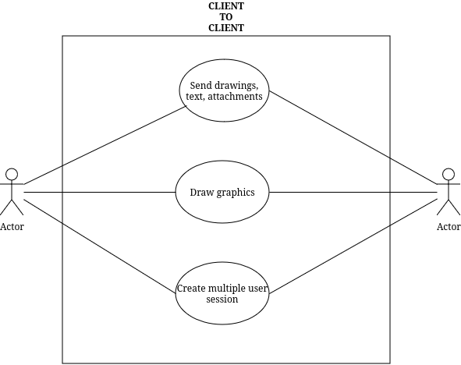

## Client-to-Server

# Sequence Diagrams

## Login

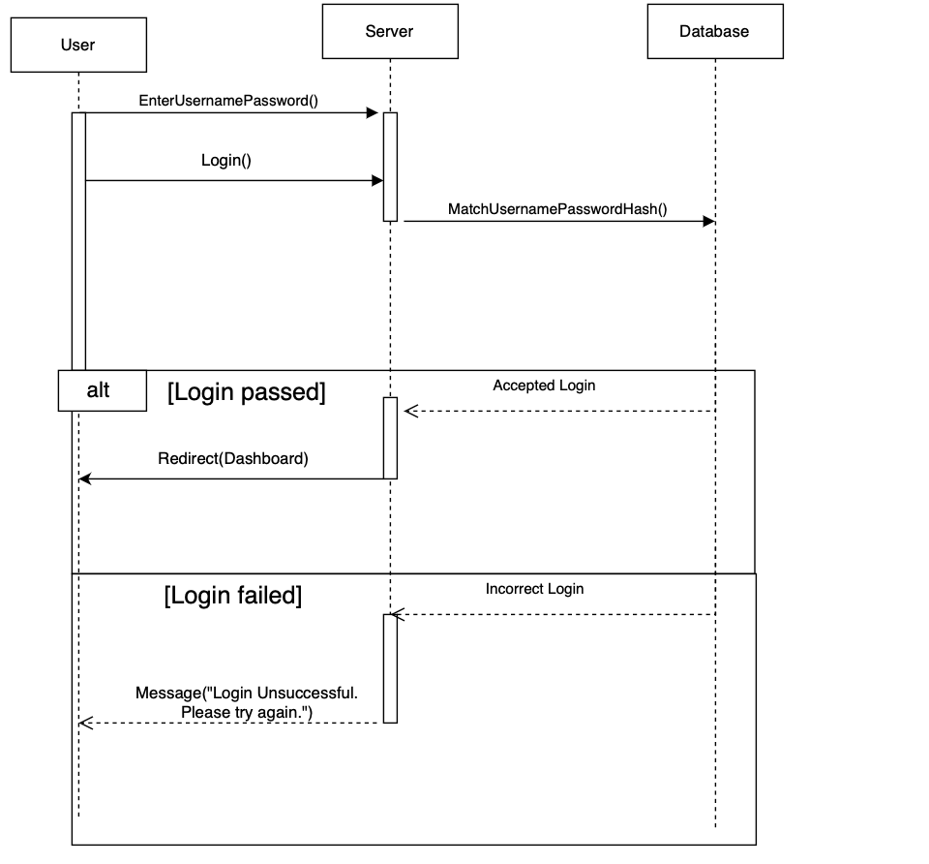

## Create Group Session

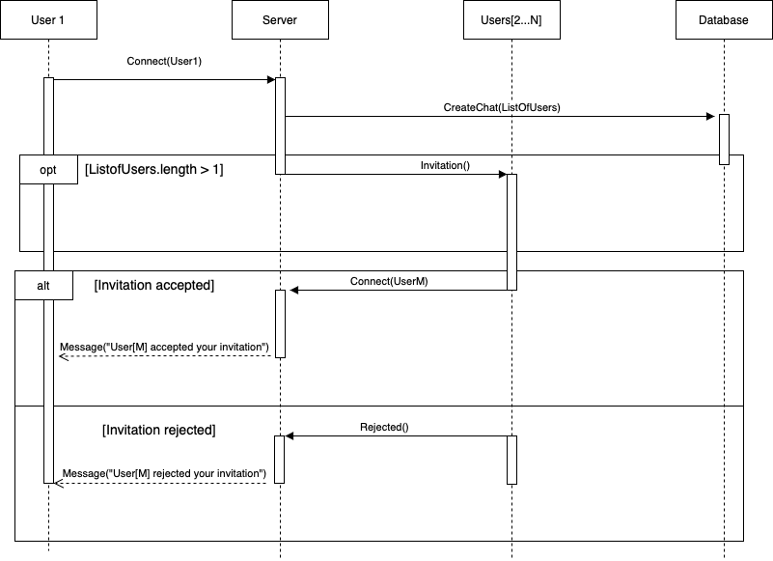

## 

## Edit Message

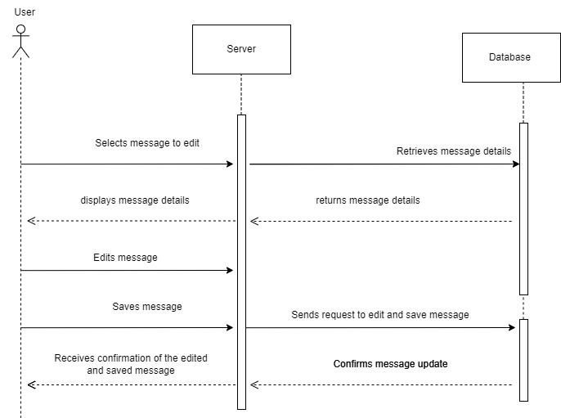

## Send Message

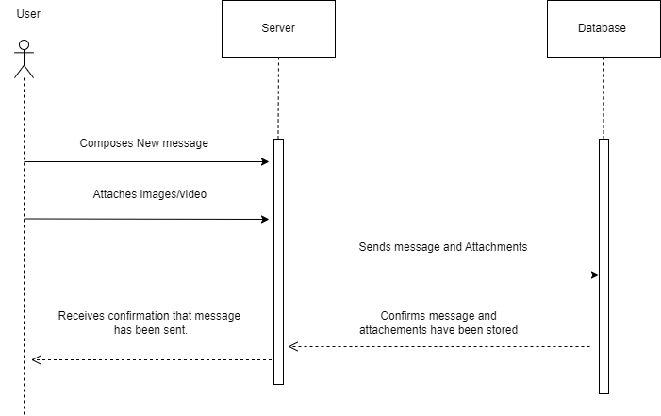

## Draw

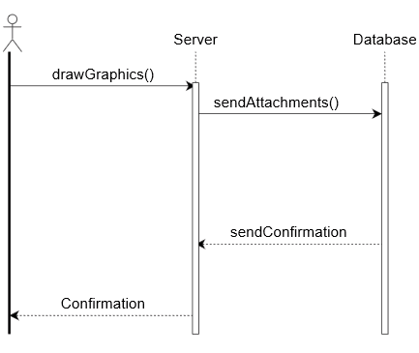

## Save Drawings

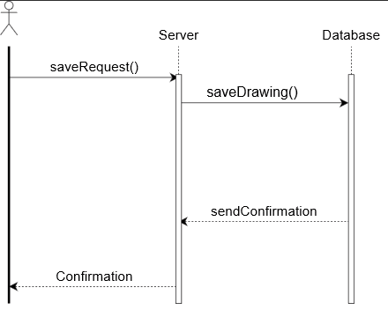

## Retrieve Drawings

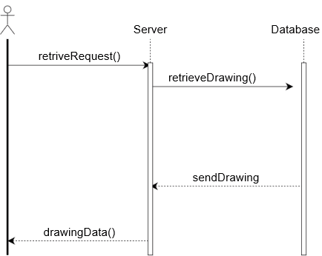

## Draw Graphics



# Class Diagram

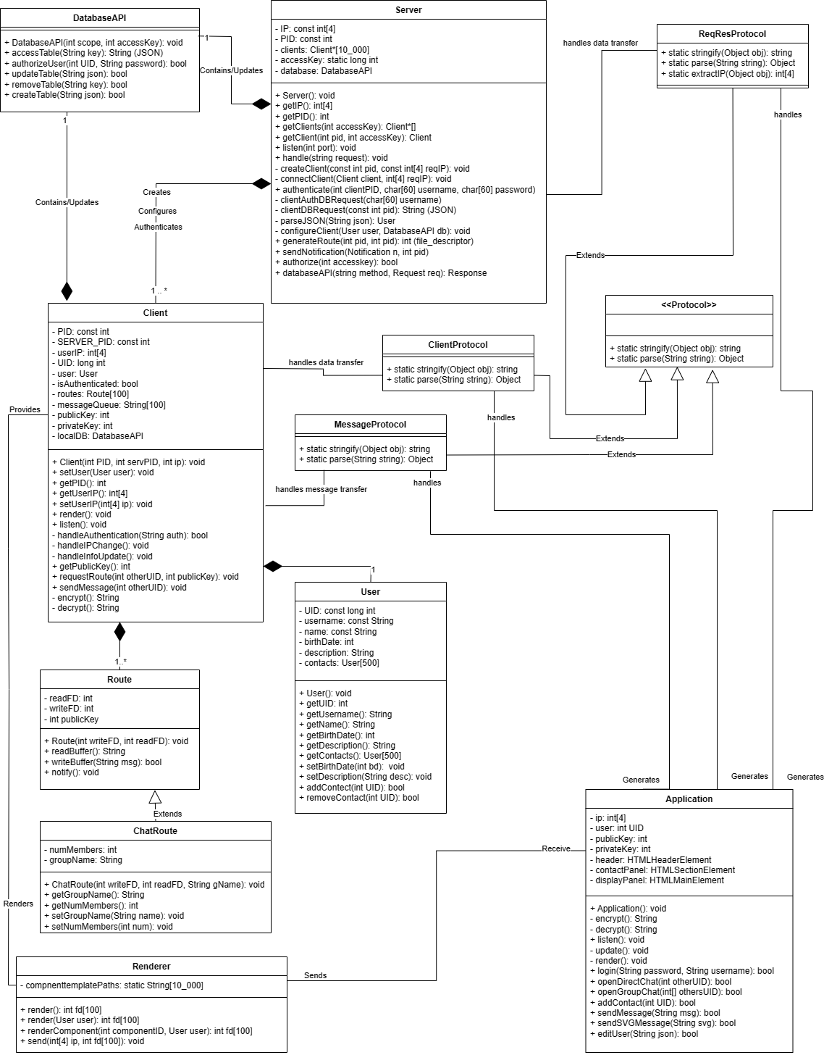

# Architectural Design

